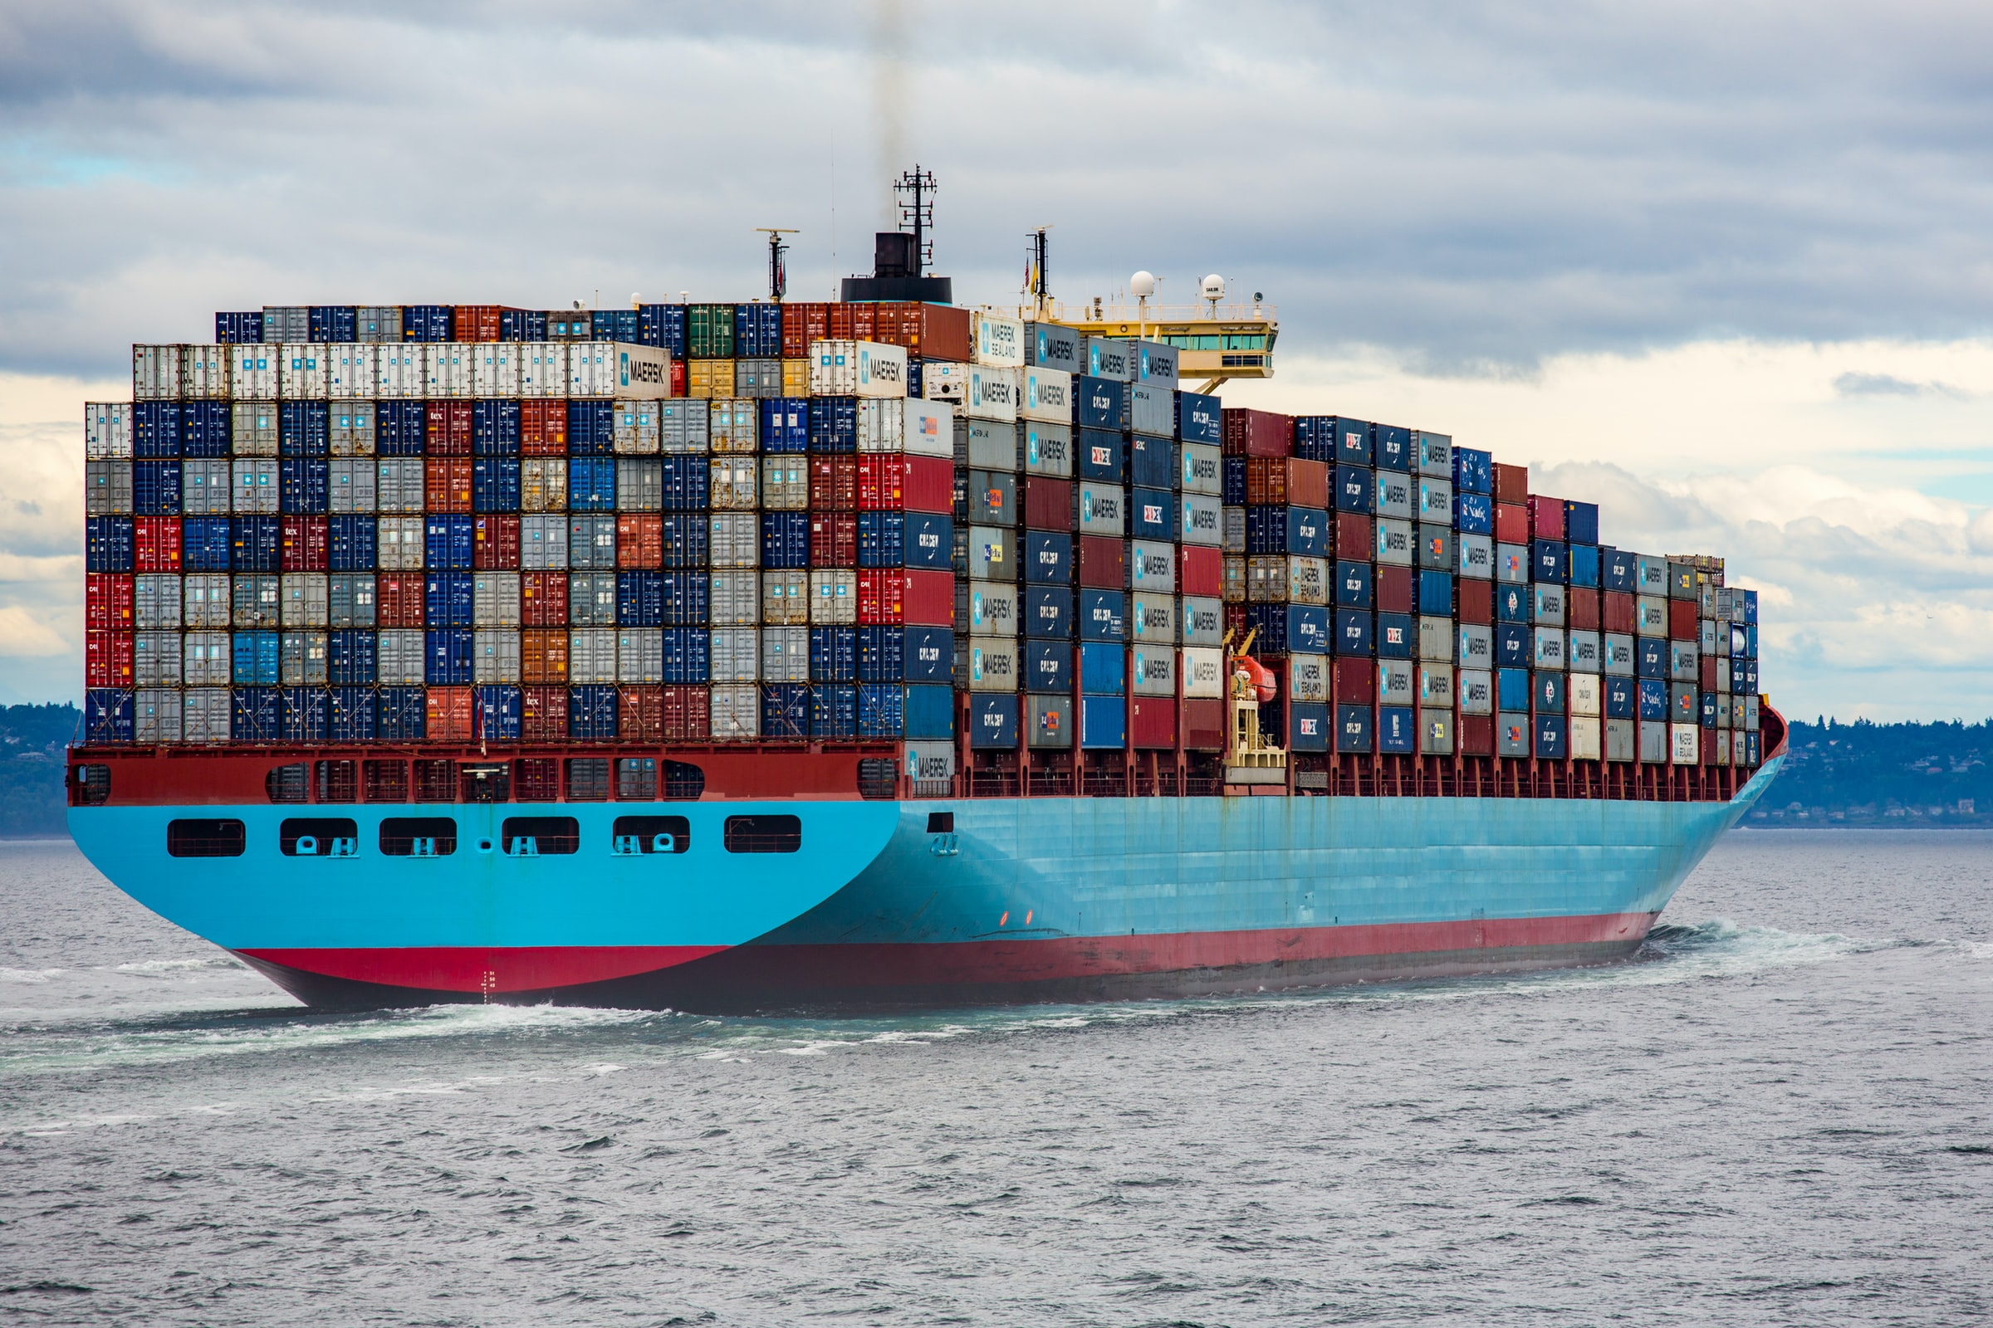

Vessel Report

Comparisson and Compilling of Different Cargo ships

Diogo Dias – 1161605 | Duarte Dias - 1190539| LAPR3

Index

Introduction 2

Description 2

MSC BRIANNA – IMO 9103685 2

CERULEAN - IMO 9655169 2

OOCL HONG KONG - IMO 9776171 3

Comparison 4

Conclusion 4

References 5

# Introduction

This Technical Team has the privilege to present the reader with the information requested by the Client[1] regarding the technical evaluation of the differences between 3 types of Vessels that can transport Cargo in containers. These 3 difference types of vessels are distinguished by the location of the Bridge in the Vessel but also by many other aspects that we will discuss in this document.

Our hope lies in bringing some light to this subject and helping you gain more knowledge in this area. We will firstly start by presenting a brief description of the Vessels followed by a side-by-side comparison of them. In the conclusion we pretend to shed some new light and help you understand the key difference between them.

# Description

Our team wanted you to be able to analyze which ship individually and then to really dive into the key differences so in here you can read and understand a little bit about these ships and their key features.

## MSC BRIANNA – IMO 9103685

The MSC Brianna[2] is a Container Ship built in 1996 and operated by the MSC company. It sails under the flag of Panama and usually does the Mediterranean Routes between the South of Spain and Malta. It’s one of the many examples of ships with the Bridge near the Stern.

It was built in 1996 and sailed already under Netherlands and British flags. It has 32 meters of beam and 294 lengths overall. Its gross Tonnage is 51931 and summer deadweight is 60200(t).

## CERULEAN - IMO 9655169

The Cerulean[3] is a General Cargo Ship built in 2013 and operated by the SE SHIPPING LINES company. It sails under the flag of Singapore and usually does the Atlantic Norte Routes between Canada and the Northern Asia. It’s one of the many examples of ships with the Bridge near the Bow.

It has 26 meters of beam and 168 lengths overall. Its gross Tonnage is 19454 and summer deadweight is 25240 (t).

## OOCL HONG KONG - IMO 9776171

The OOCL Hong Kong[4] is a Container Ship built in 2017 and operated by the OOCL company. It sails under the flag of Hong Kong and usually does the North Sea Routes between the Baltic and Nether Region. It’s one of the many examples of ships with the Bridge in the middle.

It has 59 meters of beam and 400 lengths overall. Its gross Tonnage is 210890 and summer deadweight is 191422 (t).

# Comparison

|  |  |  |  |
| --- | --- | --- | --- |
| **Vessel Name** | **MSC BRIANNA** | **CERULEAN** | **OOCL HONG KONG** |
| **Length overall** | 294 | 168 | 399.870 |
| **​Breadth** | 32 | 26 | 58.8 |
| **Deadweight** | 60200 | 25240 | 191422 |
| **Gross Tonnage** | 51931 | 19454 | 210890 |
| **Container Carrying Capacity** | - | - | ​21,413 TEU |
| **​IMO Number** | 9103685 | 9655169 | 9776171 |
| **Official Number** | - | - | HK- 4755 |
| **Call Sign** | 3FVZ7 | 9V9934 | VRQL9 |
| **Flag** | Panama | Singapore | Hong Kong |
| **Ship Type** | Container Ship | General Cargo Ship | Container Ship |
| **Year of Built** | 1996 | 2013 | 2017 |
| **Port Calls (2021)** | 68 | 15 | 46 |
| **Travelled Distance (2021)** | 94162 | 46120 | 103682 |

# Conclusion

With this analysis we can conclude that, the new ships are being built with the Bridge in the middle because of the efficient gains it provides. In the 90’s many ships, especially small ones, where build with the bridge at the bow but this no are being decommissioned or replaced by other ones.

# References

[1] “Integrative Project – Project Assignment LEI - 2021/2022.” 2022, Accessed: Jan. 21, 2022. [Online]. Available: https://moodle.isep.ipp.pt/pluginfile.php/185144/mod_resource/content/0/LEI-21-22-Sem03 - Project Assignment_v4.0.pdf.

[2] “MSC BRIANNA, Container Ship - Details and current position - IMO 9103685 MMSI 353612000 - VesselFinder.” https://www.vesselfinder.com/vessels/MSC-BRIANNA-IMO-9103685-MMSI-353612000 (accessed Jan. 20, 2022).

[3] “CERULEAN, General Cargo Ship - Details and current position - IMO 9655169 MMSI 566819000 - VesselFinder.” https://www.vesselfinder.com/vessels/CERULEAN-IMO-9655169-MMSI-566819000 (accessed Jan. 20, 2022).

[4] “OOCL HONG KONG, Container Ship - Details and current position - IMO 9776171 MMSI 477333500 - VesselFinder.” https://www.vesselfinder.com/vessels/OOCL-HONG-KONG-IMO-9776171-MMSI-477333500 (accessed Jan. 20, 2022).